MINI PROJECT REPORT

ON

COVID AND VACCINATION SYSTEM

Submitted in partial fulfillment for the VI Semester, BE, Information Science & Engineering

Prescribed By:

VISVESVARAYA TECHNOLOGICAL UNIVERSITY

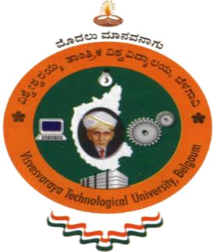

Submitted By
SANDHYA SHANBHAG 1GA18IS046
VENKAT CHAVAN 1GA18IS061

Under the guidance of
Mrs. Jyothi Neeli
Asst. Professor,
Dept. of ISE, GAT



2020-2021

DEPARTMENT OF INFORMATION SCIENCE & ENGINEERING

GLOBAL ACADEMY OF TECHNOLOGY
BANGALORE – 560098

GLOBAL ACADEMY OF TECHNOLOGY

(Affiliated to VTU, Belgaum)

Rajarajeshwarinagar, Ideal Homes Township, Off Mysore Road,

Bangalore - 560098

DEPARTMENT OF INFORMATION SCIENCE & ENGINEERING

CERTIFICATE

Certified that the Mini Project entitled COVID AND VACCINATION SYSTEM carried out by SANDHYA SHANBHAG [1GA18IS046] and VENKAT CHAVAN [1GA18IS061] bonafide student of VI Semester, in partial fulfillment for the award of Bachelor of Engineering in Information Science & Engineering, of the Visvesvaraya Technological University, Belgaum, during the year 2020-2021. It is certified that all corrections/suggestions indicated for internal assessment have been incorporated in the report. This seminar report has been approved as it satisfies the academic requirements for Mini Project (18CSMP68) prescribed for the said degree.

Signature of the Guide Signature of the HOD

Name of Examiners Signature of Examiners

1.________________ ____________________

2. ________________ ____________________

